**Module 7 - Spring REST using Spring Boot 3**

**Hello World RESTful Web Service**

**Structure:**

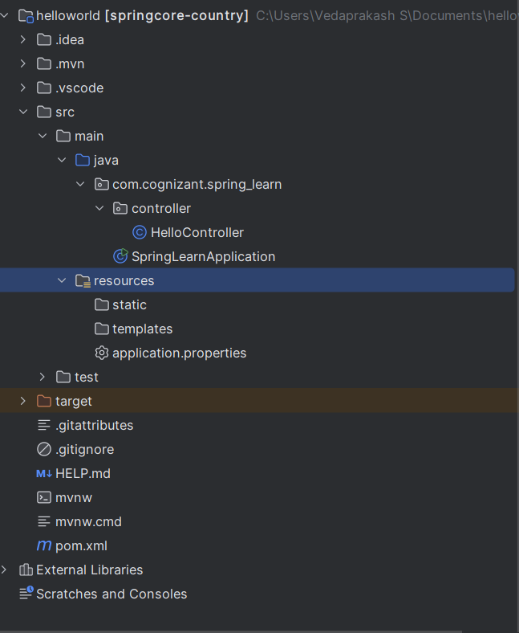

**HelloController.java:**

package com.cognizant.spring_learn.controller;  
  
import org.slf4j.Logger;  
import org.slf4j.LoggerFactory;  
import org.springframework.web.bind.annotation.GetMapping;  
import org.springframework.web.bind.annotation.RestController;  
  
@RestController  
public class HelloController {  
  
 private static final Logger *LOGGER* = LoggerFactory.*getLogger*(HelloController.class);  
  
 @GetMapping("/hello")  
 public String sayHello() {  
 *LOGGER*.info("START - sayHello()");  
 String message = "Hello World!!";  
 *LOGGER*.info("END - sayHello()");  
 return message;  
 }  
}

**SpringLearnApplication.java:**

package com.cognizant.spring_learn;  
  
import org.springframework.boot.SpringApplication;  
import org.springframework.boot.autoconfigure.SpringBootApplication;  
  
@SpringBootApplication  
public class SpringLearnApplication {  
 public static void main(String[] args) {  
 SpringApplication.*run*(SpringLearnApplication.class, args);  
 }  
}

**application.properties.java:**  
server.port=8083

**pom.xml:**

<project xmlns="http://maven.apache.org/POM/4.0.0"  
 xmlns:xsi="http://www.w3.org/2001/XMLSchema-instance"  
 xsi:schemaLocation="http://maven.apache.org/POM/4.0.0  
 http://maven.apache.org/xsd/maven-4.0.0.xsd">  
  
 <modelVersion>4.0.0</modelVersion>  
  
 <groupId>com.cognizant</groupId>  
 <artifactId>spring-learn</artifactId>  
 <version>0.0.1-SNAPSHOT</version>  
 <packaging>jar</packaging>  
  
 <name>spring-learn</name>  
 <description>Spring Boot Hello World REST API</description>  
  
 <parent>  
 <groupId>org.springframework.boot</groupId>  
 <artifactId>spring-boot-starter-parent</artifactId>  
 <version>3.2.4</version> <!-- You can change to a stable version you're using -->  
 <relativePath/> <!-- lookup parent from repository -->  
 </parent>  
  
 <properties>  
 <java.version>17</java.version> <!-- Or 21 if you're using JDK 21+ -->  
 </properties>  
  
 <dependencies>  
 <!-- Spring Web for REST Controller -->  
 <dependency>  
 <groupId>org.springframework.boot</groupId>  
 <artifactId>spring-boot-starter-web</artifactId>  
 </dependency>  
  
 <!-- Logging with SLF4J & Logback -->  
 <dependency>  
 <groupId>org.springframework.boot</groupId>  
 <artifactId>spring-boot-starter-logging</artifactId>  
 </dependency>  
  
 <!-- Optional: For Testing -->  
 <dependency>  
 <groupId>org.springframework.boot</groupId>  
 <artifactId>spring-boot-starter-test</artifactId>  
 <scope>test</scope>  
 </dependency>  
 </dependencies>  
  
 <build>  
 <plugins>  
 <!-- Spring Boot Maven Plugin -->  
 <plugin>  
 <groupId>org.springframework.boot</groupId>  
 <artifactId>spring-boot-maven-plugin</artifactId>  
 </plugin>  
 </plugins>  
 </build>  
  
</project>

**Output:**

